

Boot Camp Part 1: Congruent Figures

What does it mean to be congruent?

**Two *polygons* are congruent if and only if their corresponding parts are congruent.**

What are the different corresponding parts of a triangle?

a.

*examples:*

b.

*examples:*

Congruence Statement: _______________________

Level 1: Identify all the congruent corresponding parts. Then write a congruence statement.

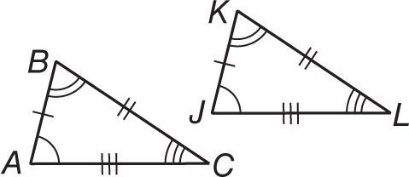1. 2.

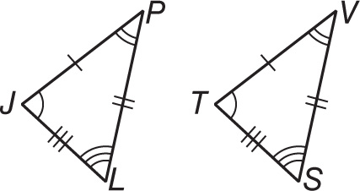 3.

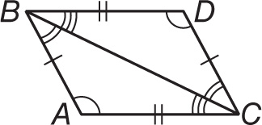Level 2: Identify all the congruent corresponding parts. Then write a congruence statement.

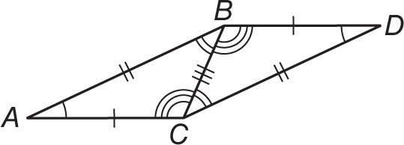4. 5.

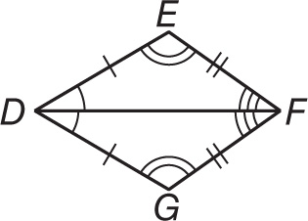 6.

Boot Camp Part 2: Identifying Congruent Parts

Level 1: Mark the angles and sides of each pair of triangles to indicate that they are congruent.

1. 2.

F

L

R

Q

G

V

H

M

K

U

W

Level 2: Complete each congruence statement by naming the corresponding angle or side.

3. 4. 5.

Boot Camp Part 3: Congruency and Algebra

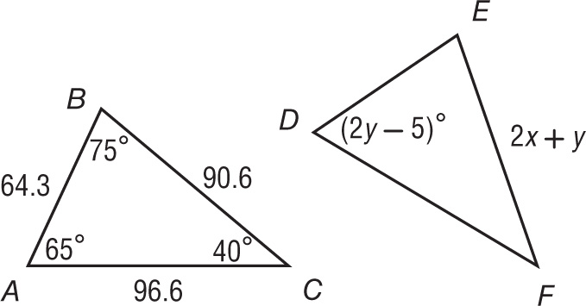Level 1: Suppose △*ABC* ≅ △*DEF*. Find each value below.

1. *x* = _________ 2**.***y* = _________

3**.** = ______ 4**.** = _______

**Third Angles Theorem: If two angles of one triangle are congruent to two angles of a second triangle, then the third angle of the triangles are congruent.**

Level 2: Find each angle measure.



2.

1.