**Geometry: Semester 1 Final Review**

**Chapter 1: Tools of Geometry**



1. 3



1. 3



1. 3

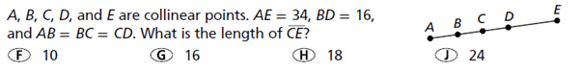

1. 5
2. Find  .
3. What is the difference between a linear pair and supplementary angles?
4. $∠$ A and $∠$ B are supplementary. The measure of $∠$ A is 18 $°$ less than the measure of $∠$ B. Find the measure of each angle.
5. $∠$ A and $∠$ B are complementary. The measure of $∠$ B is 4 times the measure of $∠$ A. Find the measure of each angle.

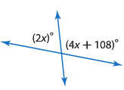  
  
  
  
Find the value of each variable in #9-12.

1. 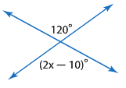 3 10.

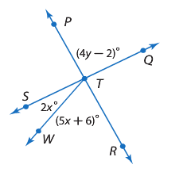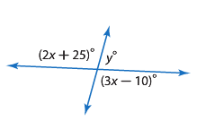

1. 3 12. $∠$ STR is a right angle  
    5 $∠$ PTQ is a right angle

13. Find CD. C($-$ 4, $-$ 6), D(5, $-$ 1) 14. Find the midpoint of $\overline{CD}$. C(4, 6), D(5,1)

15. Find AB. A(2, $-$ 3), B(5, 6) 16. Find the midpoint of $\overline{AB}.$ A(2, $-$ 3), B(5, 6)

**Chapter 2**

**Identify the property:**

1. If *AB* = *CD*, then *AB* + *BC* = *CD* + *BC*.
2. If  and , then .
3. If , then *x* = 30.
4. If *XY* + *CD* = 30 and *XY* = 12, then 12 + *CD* = 30.
5. If 88 = 2*x*, then 44 = *x*.
6. If *x* + 32 = 18, then *x* = –14.
7. If the Chiefs beat the Raiders and the Raiders beat the Broncos, then the Chiefs should beat the Broncos.

**Chapter 3A**

24. What type of angle pair are 

25. What type of angle pair are 

26. What is ?

**Solve the following systems of equations.**

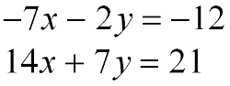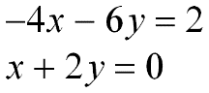27. 28.

**Chapter 3B**

29. Are the graphs of the following equations parallel, perpendicular, or oblique? EXPLAIN WHY!

a) b)

 c) d)

30. Write an equation of the line that passes through (1, 2) and is parallel to .

31. Write an equation of the line that passes through (7, 4) and is perpendicular to .

32. Write an equation of the line that passes through the points (5, -3) and (-2, 3).

33. Find the slope of . A(-3, -2) B(2, -5)

34. Find the slope of  A(5, -6) B(5, -3)

35. Find the slope of  A(-2, 3) B(5, 3)

36. Graph the following lines.

a) -3x – 2y = 8 b) 

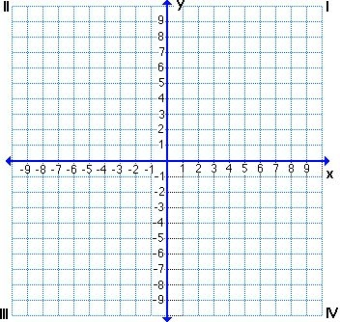

**Chapter 4A: Triangles**

**Directions: Find the missing variables in 37-44 below.**

*2x* ° (3*y*+11)°

(4*y* - 5)°

37. 38. 39.

*x* ° *y*°

*x*°

*y*°



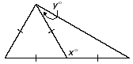40. 41. 42.

*x* ° 72°

*y*°



43. 44.

45. Determine whether the following side lengths could form a triangle.

a. b. c.

46. In,. If and $AC = 5-4x$. What would the perimeter of the triangle be?

**Chapter 4B: Triangle Proofs**



47. **Given:**  bisects , 

**Prove:** ∆ABD  ∆ACD

Statements Reasons

1.  bisects  1.

2. 2.

3.  3.

4. 4. Def. of 

5. 5. all rt. 

6. 6. reflexive

7. 7.

48. **Given:** 

**Prove:** 

Statements Reasons

1. 1.

2. 2.

3. 3.

4. 4.

5. 5.

**4**9. **Given:** , 

**Prove:** ∆ACD ∆CAB

Statements Reasons

1. 1.

2. 2.

3. 3.

4. 4.

5. 5.

Can you prove these triangles are congruent? If yes, state the postulate, if no, explain why not.

50. 51.

Congruent: yes no Congruent: yes no

If yes, Postulate:___________ If yes, Postulate:___________

If no, Explain: If no, Explain:

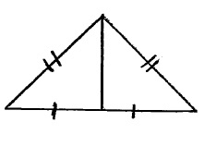52. 53.

Congruent: yes no Congruent: yes no

If yes, Postulate:___________ If yes, Postulate:___________

If no, Explain: If no, Explain:

**Chapter 9: Transformations**

**Directions: Graph each figure and its image along the given vector.**

54**.** quadrilateral *TUWX* with vertices 55.pentagon *DEFGH* with vertices *D*(–1, –2),

*T*(–1, 1), *U*(4, 2), *W*(1, 5), and *X*(–1, 3); *E*(2, –1), *F*(5, –2), *G*(4, –4), and *H*(1, –4);

〈–2, –4〉 〈–1, 5〉

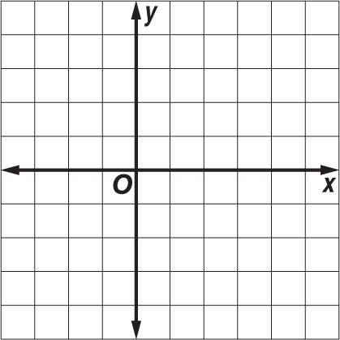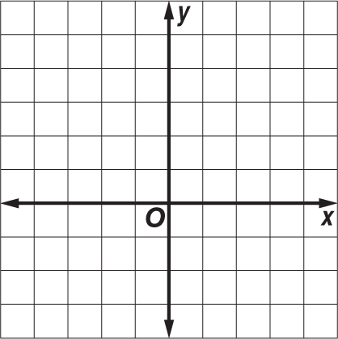

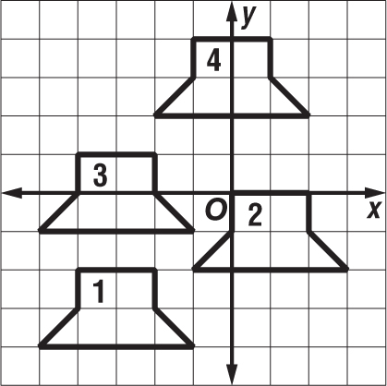**Directions : Given the figure, write the translation vector from:**

56.figure 1 → figure 2

57.figure 3 → figure 4

58. Which of the following figures shows a translation?

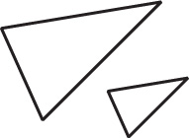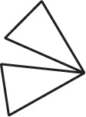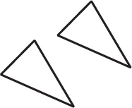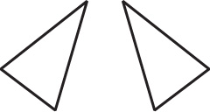 **F G H J**

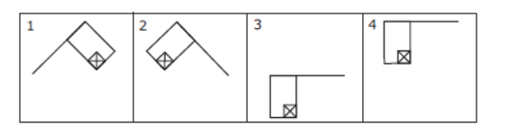59. Which of the following best describes the movement of the flag from picture to picture? (G.5C)

1. Reflection, rotation, translation
2. Rotation, translation, translation
3. Rotation, translation, dilation
4. Reflection, translation, translation

60. Directions: Identify the type of rigid transformation being displayed (reflection, translation, or rotation).

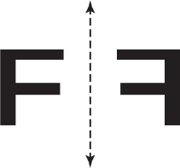 a).b).

A

A’

B

C

C’

B’

**Semester 1 Vocabulary**

point line plane collinear

coplanar segment endpoint ray

opposite rays postulate theorem midpoint

bisector angle vertex acute angle

obtuse angle right angle straight angle adjacent angles

linear pair supplementary complementary vertical angles

hypotenuse biconditional parallel lines perpendicular lines

skew lines oblique lines transversal scalene

isosceles equilateral equiangular corresponding angles

slope CPCTC mid-segment alternate interior angles

congruent rotation translation alternate exterior angles

leg reflection consecutive interior angles

**Foundations of Geometry**

***Be able to draw and label:***

Line

Plane

Segment

Ray

Opposite rays

Angle – acute, obtuse or right

Collinear points

**Formulas**

***Know, and be able to use, the following formulas:***

Distance

Midpoint

Slope

**Theorems, Postulates, and Properties**

***Know the following properties:***

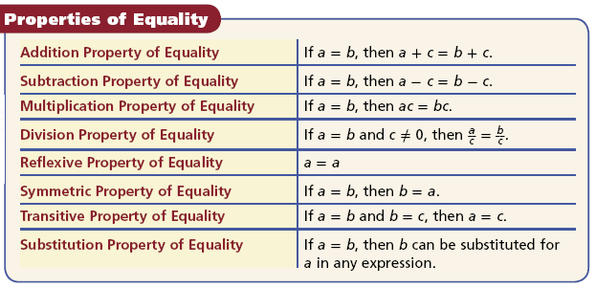

***Know the following postulates:***

Angle Addition Postulate

Segment Addition Postulate

***Know the following theorems:***

Triangle Sum Theorem

Exterior Angle Theorem

***Know the following postulates/theorems for proving triangles congruent:***SSS

SAS

ASA

AAS

HL

Do NOT work: SSA, AAA